The third edition of the 'DevOps Shop' series, '**Linter Wonderland + AI Assistant for Developers**', is live now!

Linting is a simple, yet effective, way to test and clean up your code during the build phase of continuous integration. If you are currently skipping linting, you could be living in a ‘linter winter’ which could be making your code, at best - inefficient, and at worst - a security liability.

In this video, you will see tried, tested and true ‘lint hints’ and how automation can make linting a relatively painless process. You’ll also learn about various Python linters, and how the benefits of linting for security and automation should have you ‘sprinting for linting’.

Last, but not least, we will introduce and demonstrate Tabnine, the powerful AI assistant for developers you can use in your IDE, on your laptop, on a server behind your firewall, or in the cloud. Tabnine is powered by machine learning models pre-trained on open-source code with permissive licenses and it features whole and full-function code completion. Privacy is paramount with Tabnine, so you code will remain private...and it offers a FREE plan too!

Check it out now!

Previous editions of DevOps Shop

**1**. [Intro to Cisco Modeling Labs](https://community.cisco.com/t5/devops-blogs/intro-to-cisco-modeling-labs-devops-shop-series/ba-p/4749861)

[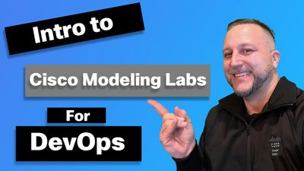](https://community.cisco.com/t5/devops-blogs/intro-to-cisco-modeling-labs-devops-shop-series/ba-p/4749861)

**2**. [9 Easy-to-Use Python Modules for DevOps](https://community.cisco.com/t5/devops-blogs/9-easy-to-use-python-modules-for-devops-devops-shop-series/ba-p/4767850)

[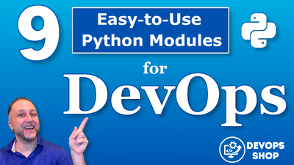](https://community.cisco.com/t5/devops-blogs/9-easy-to-use-python-modules-for-devops-devops-shop-series/ba-p/4767850)